

**BENGAL SCHOOL OF HOTEL MANAGEMENT**

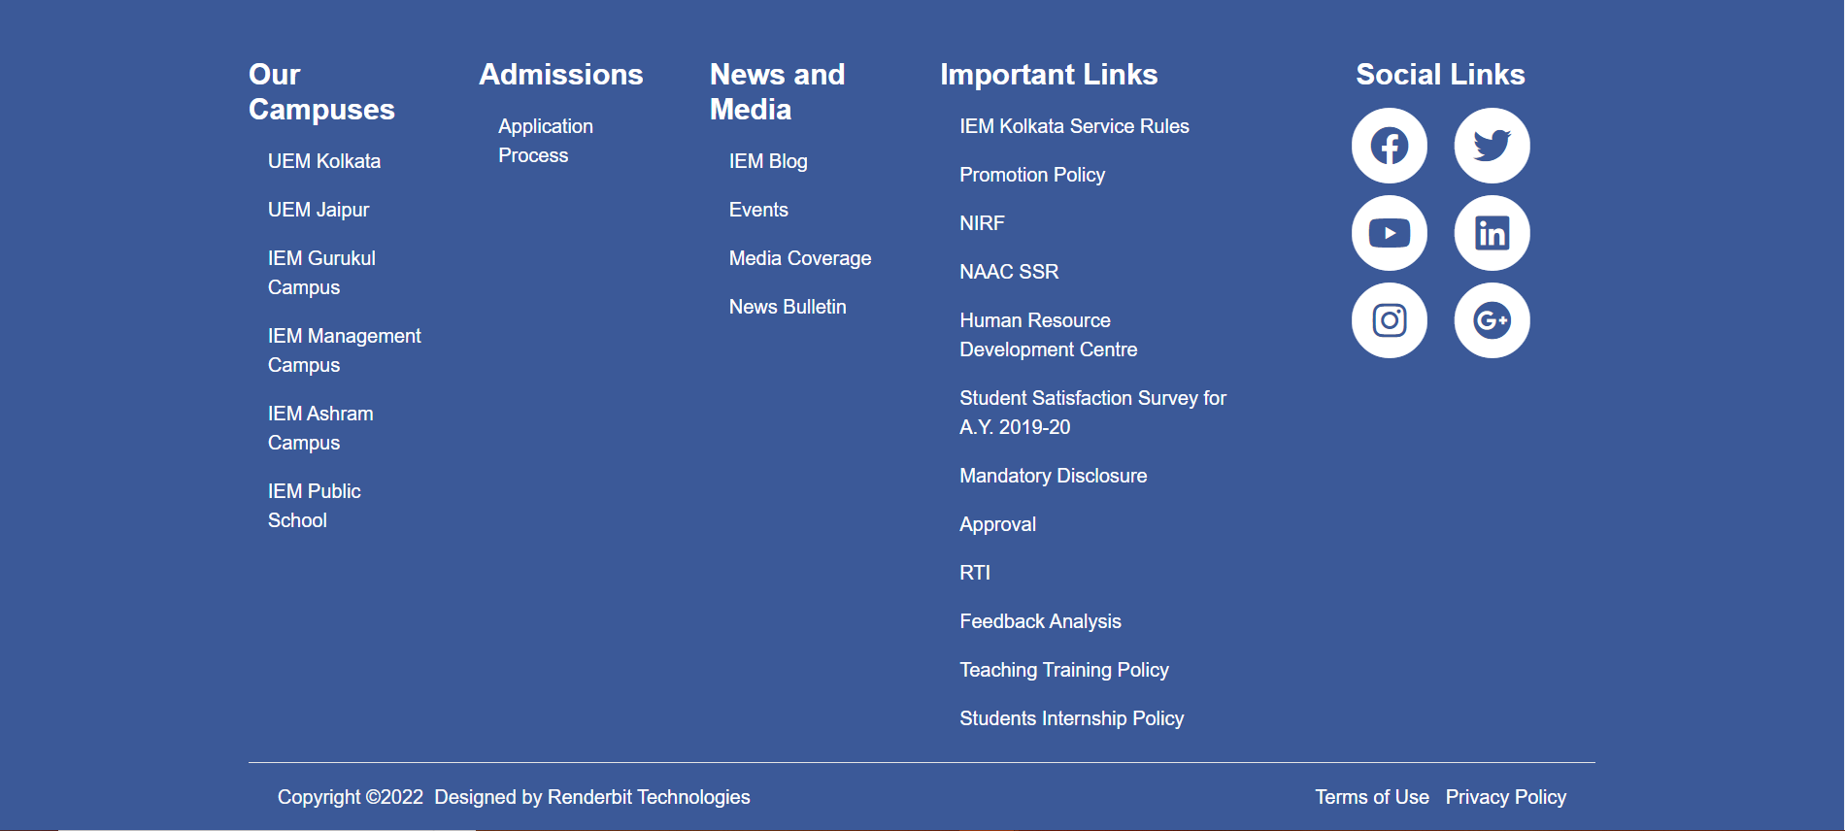Home about us gallery academics contact_us

NOTICE BOARD

